Public Coffee Machine
- System Requirements
Functional Requirements:
Payment Processing: The machine must support coin/bill insertion and contactless card payments.
Drink Selection: The system must allow users to choose different types of beverages.
Customization: Users must be able to adjust sugar levels (0–5) and choose "extra milk" where applicable.
Maintenance Alerts: The system must display an "Out of Service" message if critical ingredients are empty or if the waste container is full.
Inventory Management: The system must track levels of water, beans, milk powder, and cups.

Non-Functional Requirements:
The system shall prepare a drink within 30–60 seconds.
The system shall have uptime ≥ 99%
The machine shall be available 24/7 (except maintenance).
The system shall support multiple languages.
The system shall log all critical operations for auditing
Maintenance tasks shall be completed within 10–15 minutes.
Software updates shall be deployable without full system shutdown.

- Use case diagram
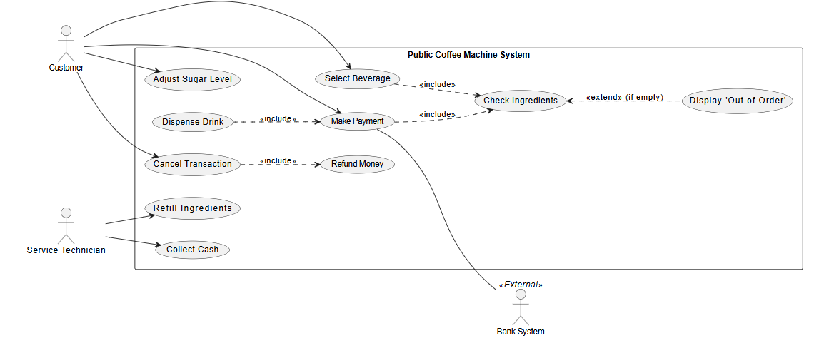
Fig. 1. Use Case Diagram for Coffee Machine

- Objects, Classes, and Relationships

Class Name | Responsibilities | Collaborators
CoffeeMachine | Acts as the central controller; manages system states (Idle, Brewing, Error); initiates the ordering process. | UserInterface, PaymentProcessor, DrinkMaker
UserInterface | Displays the beverage menu; captures user selection and sugar levels; shows real-time brewing status. | CoffeeMachine, Drink
PaymentProcessor | Validates currency; calculates change; processes cards. | Payment, CoffeeMachine
DrinkMaker | Controls the hardware sequence (grinding, heating, mixing); triggers ingredient dispensing. | Drink, Ingredient, Cup
InventoryManager | Monitors stock levels of all resources; updates quantities after each drink is successfully dispensed. | resources; updates quantities after each drink is successfully dispensed.Ingredient, CoffeeMachine
Drink | Provides a base template for all beverages, including properties like name and base price. | Ingredient
Payment | Provides a generic interface for authorizing transactions and issuing refunds. | PaymentProcessor
Coin / Card / NFC | Implements specific validation logic (e.g., physical sensor check vs. external Bank API). | PaymentProcessor
Ingredient | Stores data regarding the type and current volume of a resource (e.g., Water, Beans). | InventoryManager, DrinkMaker
Cup | Represents the physical container; tracks availability of different sizes. | DrinkMaker, InventoryManager

- Class Diagram
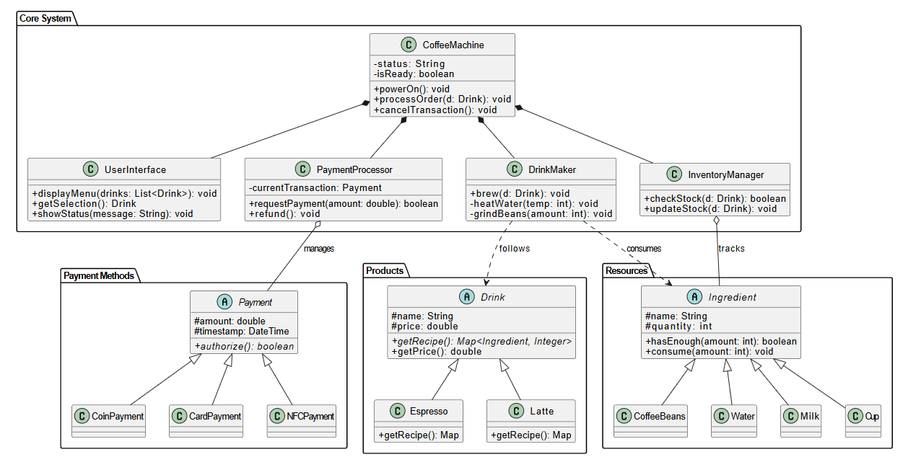
Fig. 1. Class Diagram for Coffee Machine

- Java Code
https://github.com/Sviatdev5/Coffee-Machine-Design-Learning-

